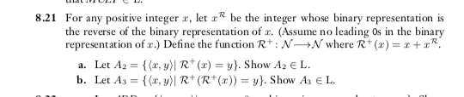

A)
Proof by contradiction

If a turning machine has all inputs for every + integer (X) and we compute all inverse of (X)
If we comput the result will always be (X). Because binary 1 + binary 0 will always result in binary 1.

Our turning machine should only accept (X) where binary can be represented in binary 1.

Ex.1, 11,111, etc..

All turning machines can accept binary 0, so A₂⋹ L

B)

Just like A, the same contradiction is assumed so if we perform computation on the same Turning machine, then we call the same function which will return the value of (X).

Our turning machine should only accept (X) where binary can be represented in binary 1.

Ex.1, 11,111, etc..

All turning machines can accept binary 0, so A₃⋹ L, as well.

